Group Assignment #4: Freight Transportation

Logistics Management, Fall 2023

**Due: 23:30, December 5, 2023 (Tuesday)**

Given the location decision in Assignment #3 Part (1), Aqua Hero decides to initially set up a distribution center in Xinpu (新埔鎮). However, it is also decided that two demand nodes in the remote area, i.e., Jianshi (尖石鄉) and Wufeng (五峰鄉), should be given up given the high cost to serve. Aqua Hero tentatively considers using just one single milk-run type of service to supply the demand nodes. Thus, Aqua Hero needs to design a route starting from the DC in Xinpu and subsequently visiting the 10 demand nodes one by one, by assuming the capacity is not an issue. The location information of the customers remains unchanged, but with the re-ordered IDs. The distance between each pair of nodes (*dij*) is updated and provided in the data file on the E3 course platform.

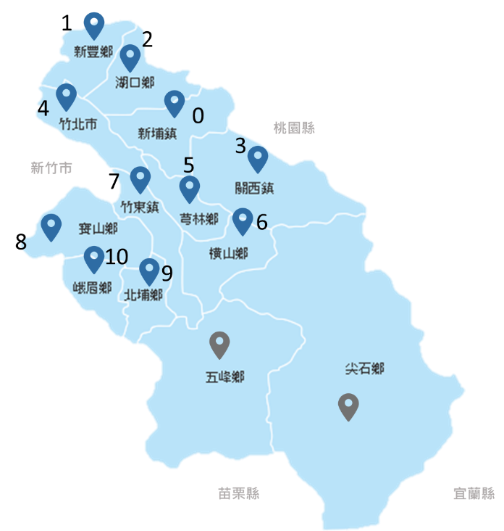 

Your team is asked to prepare an executive summary for the project of evaluating the tentative one-route arrangement starting from the distribution center in Xinpu.

1. Use both the sweep algorithm and the nearest neighbor insertion procedure to design the truck route and calculate the overall route distance (total cost).
2. Further improve the solution in Part (1) by trial and error, or solve the integer programming problem of the TSP (as in the Appendix for details).

**Appendix – An Alternative TSP Formulation**

**Set:**

*C*: Set of the DC and all customers. C = {1, 2, 3, …, *n*}

**Parameters:**

: Distance between node *i* and *j*. *i*,*jC*

**Variables :**

: Determining whether the delivery route include the link from node *i* to node *j*. *i*,*jC*

: Virtual variables to prevent the occurrence of sub-tour. *iC*

**Objective Function:**

Minimize

**Constraints:**

|  |  |  |
| --- | --- | --- |
| = 1 | *iC* | (1) |
| = 1 | *jC* | (2) |
|  | *jC* | (3) |
|  | *iC* | (4) |
|  | *jC* | (5) |